1. Open FlashDemo.exe
2. Click "Openfile", select the suffix. Bin file.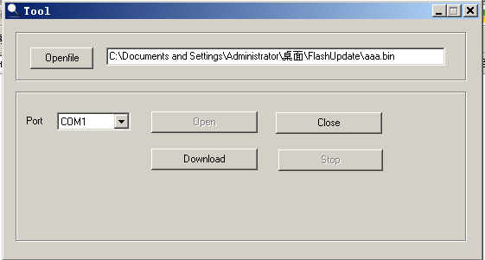
3. Select the reader and the host computer connected to the port, click "open", then click "download". At this point to the reader power, if the serial port is connected correctly, the reader into the programming mode, progress bar scrolling is being programmed. The "Stop" button is bright. If the progress bar is not scrolled, indicating that the programming mode is not entered, check the serial wiring and the steps to meet the requirements.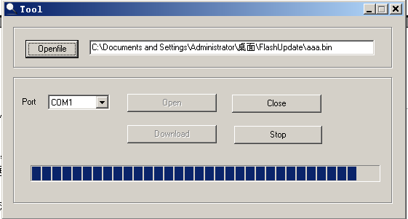
4. When the "Stop" button is grayed out, it indicates that the programming is complete and the reader is working properly. If programming fails, a "Download failed" prompt box is displayed.